PROJECT- Fall 2025
  - Deadline: 11/24/2025 @ 23:59
[Total Mark for this Assessment is 100]

Algorithm and Complexity Analysis
CSC-379-01 / CSC-575-01

Student Details:
Name: Student1  CRN: |  | ID:

Submission Instructions:
- This assignment must be submitted on Moodle pdf format only).
- The page number should appear on each page.
- All the text and diagrams must be electronically produced.
- Email submission will not be accepted.
- You are advised to make your work clear and well-presented; marks may be reduced for poor presentation. This includes filling your information on the cover page.
- You MUST show all your work, and text must not be converted into an image, unless specified otherwise by the question.
- The project proposal should contain the following sections:

Question one
25 Marks

Suppose you have the following array: {11, 22, 33, 44, 55, 66, 77}. Write a java program to find the sum of elements of the array recursively.
public class RecursiveSum{
public static void main(String[] args) {

int[] numbers = {11,22,33,44,55,66,77}; // Define array

int sum = recursiveSum(numbers, 0); // Call Recursive Function starting at the beginning of the array

System.out.println("The total of the array is: " + sum);//Print output

}
/**
* Function Name: recursiveSum
*
* @param array
* @param index
* @return
*
* Inside the function:
* 1. establishes base case for recursion, returning 0 when all indeces have been gone through
* 2. recursive call to sum all integers. Moves to next index in recursion
*
*/
public static int recursiveSum(int[]array, int index){
if (index == array.length){
return 0;
}
return array[index] + recursiveSum(array, index+1);
}
}
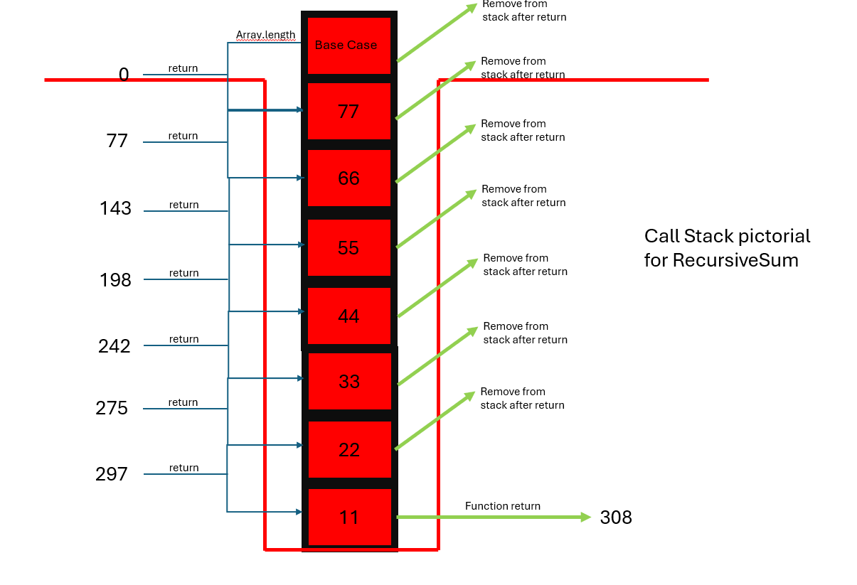

Question Two
25 Marks

Use the following method to generate an array (arr1) of 5000 randomly generated elements.
public static int[] RandomArrayGenerator(int n)
{
int[] Array = new int[n];
Random r = new Random();
for(int i=0;i<n;i++)
{
Array[i] = r.nextInt(1000);
}
return Array;
}
[Note that by using nextInt(100) you will generate an integer between 0 and 100.]
- Use insertion sort to sort arr1.
- Use RandomArrayGenerator again to create arr2 containing 5000 randomly generated element.
- Use the static sort methods of Java's Arrays class to sort arr2.
- Time each of the methods so that you can make a comparison of the efficiency. You can create longs and store the system time to know when the method starts and ends. You can then take the difference run time in milliseconds.
long startTime = System.currentTimeMillis();
//call sort method here
long endTime = System.currentTimeMillis();

Question Three
25 Marks

Suppose a program builds and manipulates a linked list:
What two special nodes would the program typically keep track of? Describe two common uses for the null reference in the node of the linked lists.
The two special nodes a linked list program would like to keep track of are the Head and the Tail Nodes. Because a linked list is stored randomly in memory, unlink an array which is stored serially, there is no inherent index property to the structure. Therefore, when looping through or interrogating the linked list, you cannot use the index values or length of the structure as you would when using an array, instead you create pointers that move along the linked list. These pointers can utilize the “Head” to know which Node begins the linked list, and the “Tail” to know which Node ends the linked list.
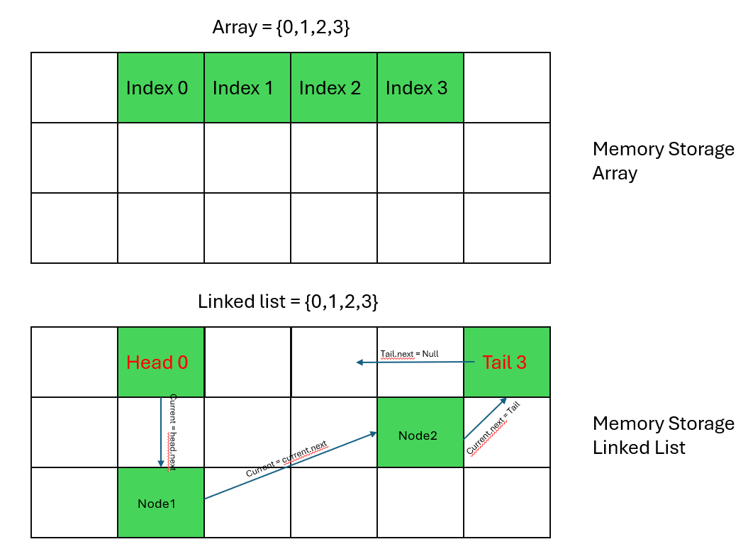
Two common uses for the null reference are as follows:
- The null reference can be used to show that a list is empty. If a function is called to return a value on a linked list that is empty, if the function does not return some value it will have, hence if the list is empty, return Null.

Question Four
25 Marks

Consider the following Java Code:
What is the output when this code is executed?
import java.util.LinkedList;
import java.util.ListIterator;
class Main {
public static void main(String[] args) {
LinkedList<String> myLList = new LinkedList<String>();
myLList.addFirst("Christophe");
myLList.addFirst("Stephen");
myLList.addLast("Christina");
ListIterator<String> myiterator = myLList.listIterator();
myiterator.next();
myiterator.next();
myiterator.add("Reem");
myiterator.previous();
myiterator.add("Ahmad");
myiterator.add("Khaled");
myiterator.previous();
myiterator.remove();
System.out.println(myLList);
myiterator.next();
myiterator.next();
System.out.println("MyList Backward iteration :");
while(myiterator.hasPrevious())
System.out.println(myiterator.previous());
System.out.println("---------------------");
}
}

---------------------

Assessment
- As indicated on the syllabus, the project proposal is 30% of your grade.
- You will be graded on the quality your project: originality, technical soundness, and report quality (grammatical errors, clarity, etc.).

